**Practical No : 3**

**Aim:** Create Simple RESTFUL service.

* **For Java Web :**
* **Step :**

1. Open NetBeans IDE.

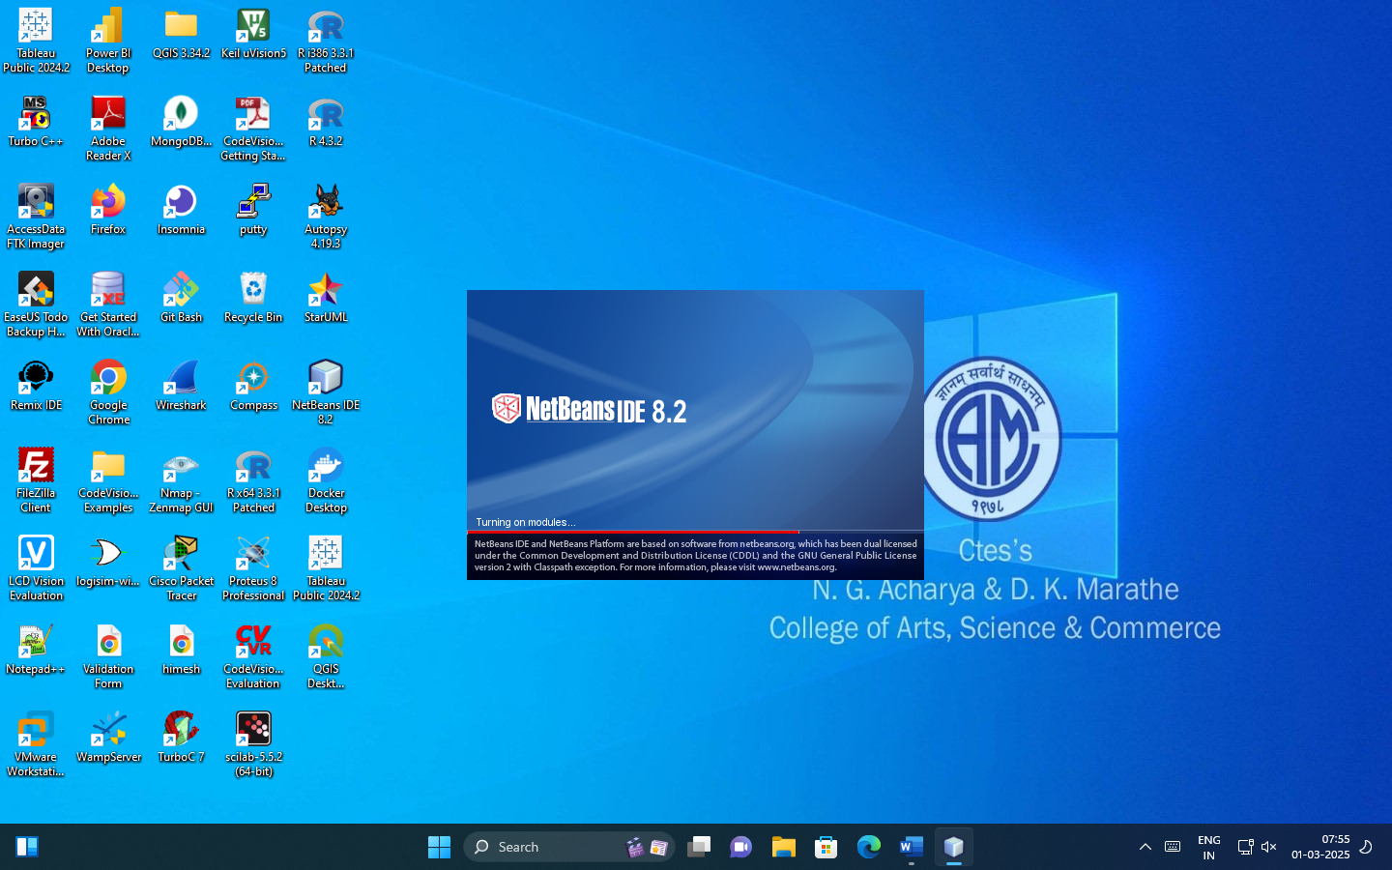

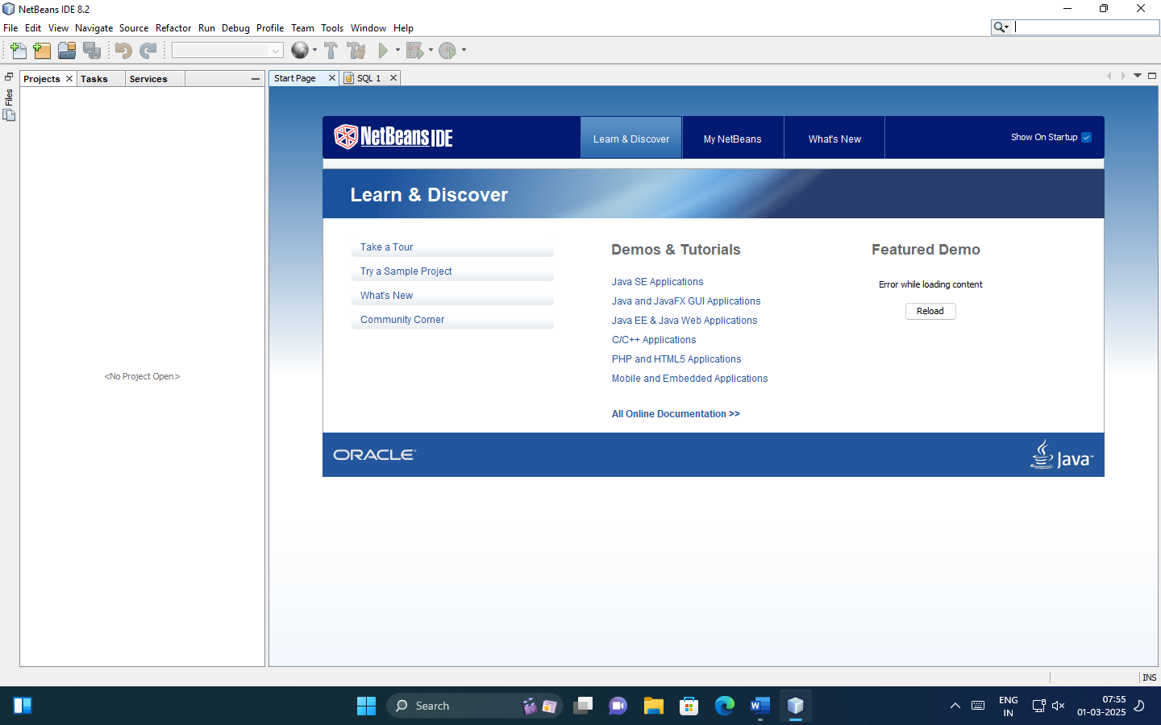

1. Select new project > Click on File > select New Project

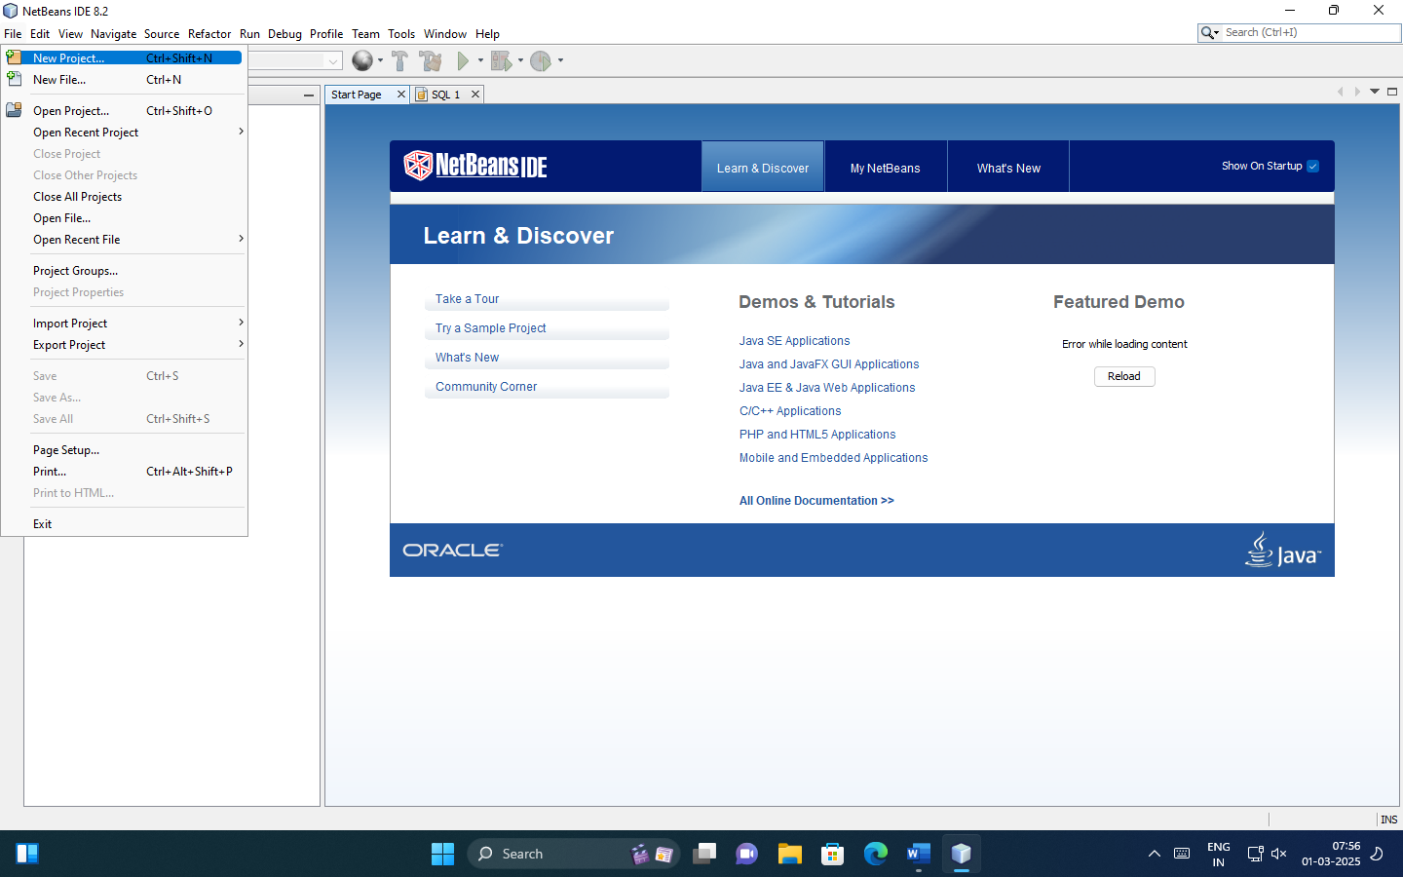

1. Select Java Web .

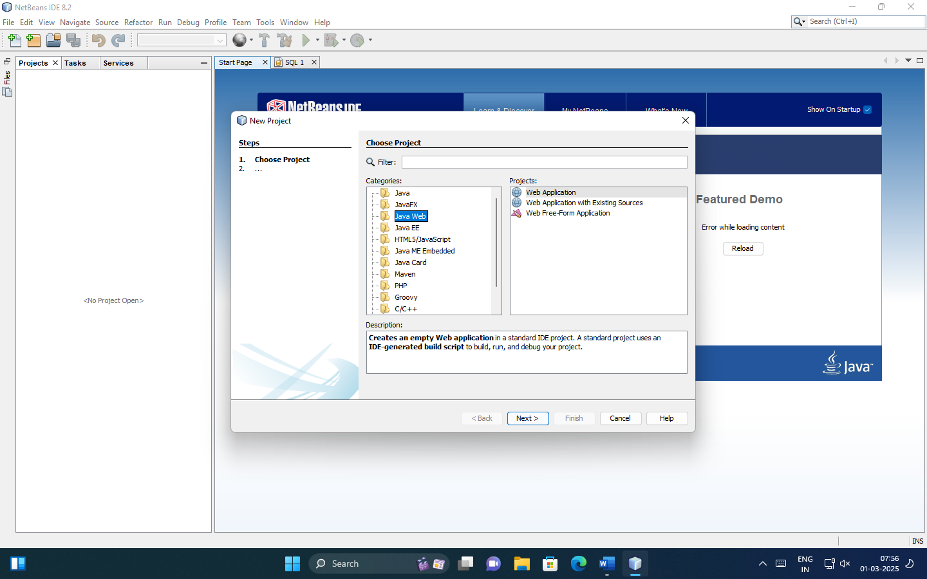

1. Select Web Application.

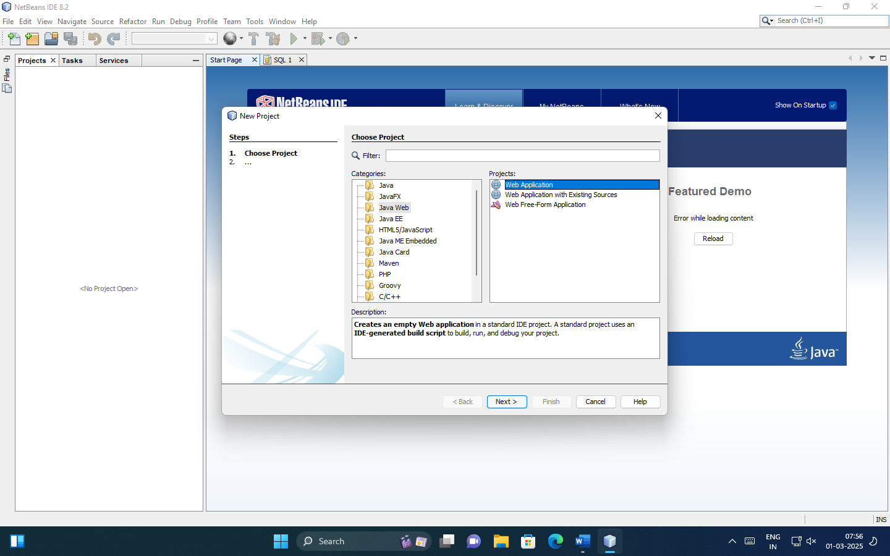

1. Give name to project and set project loaction.

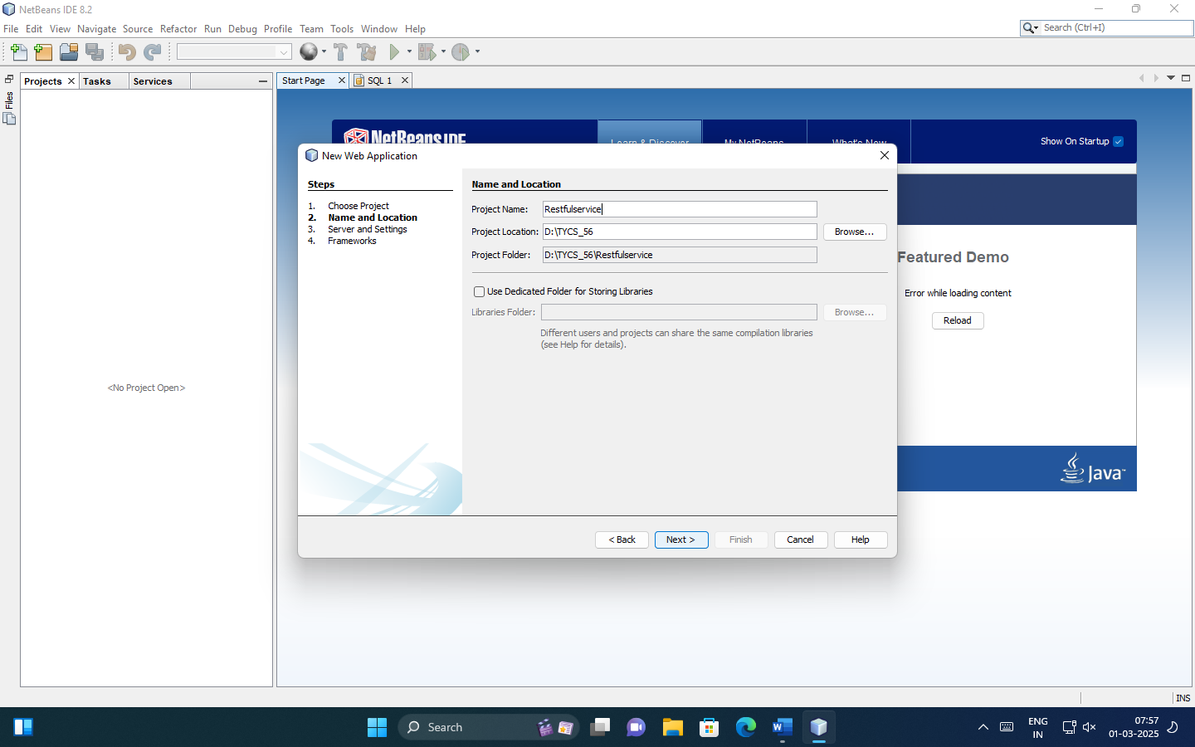

1. Select the “GlassFish server 4.1.1” > click on next

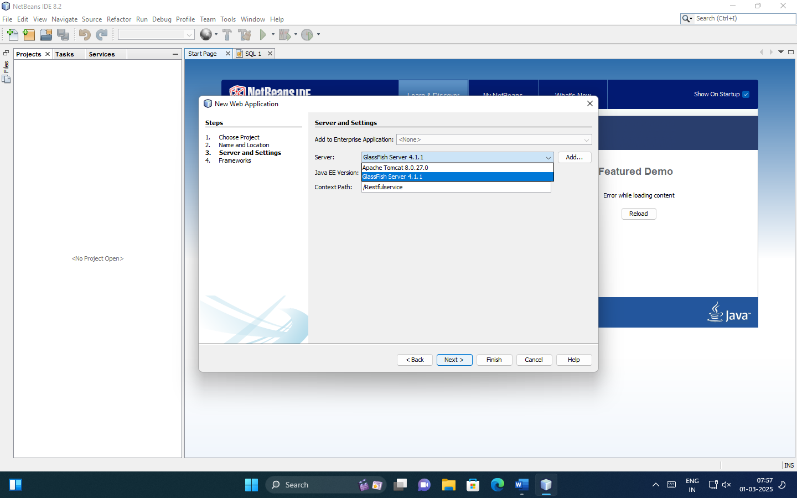

1. Click on finish

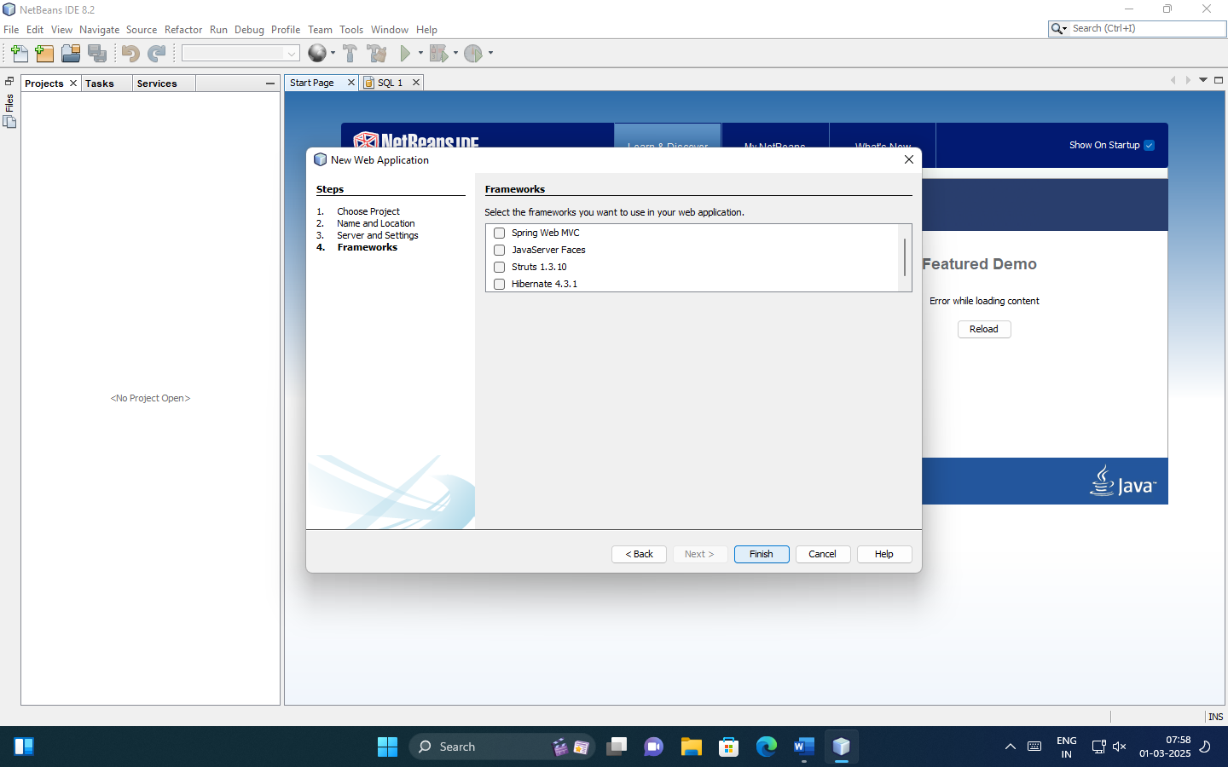

1. Select Project

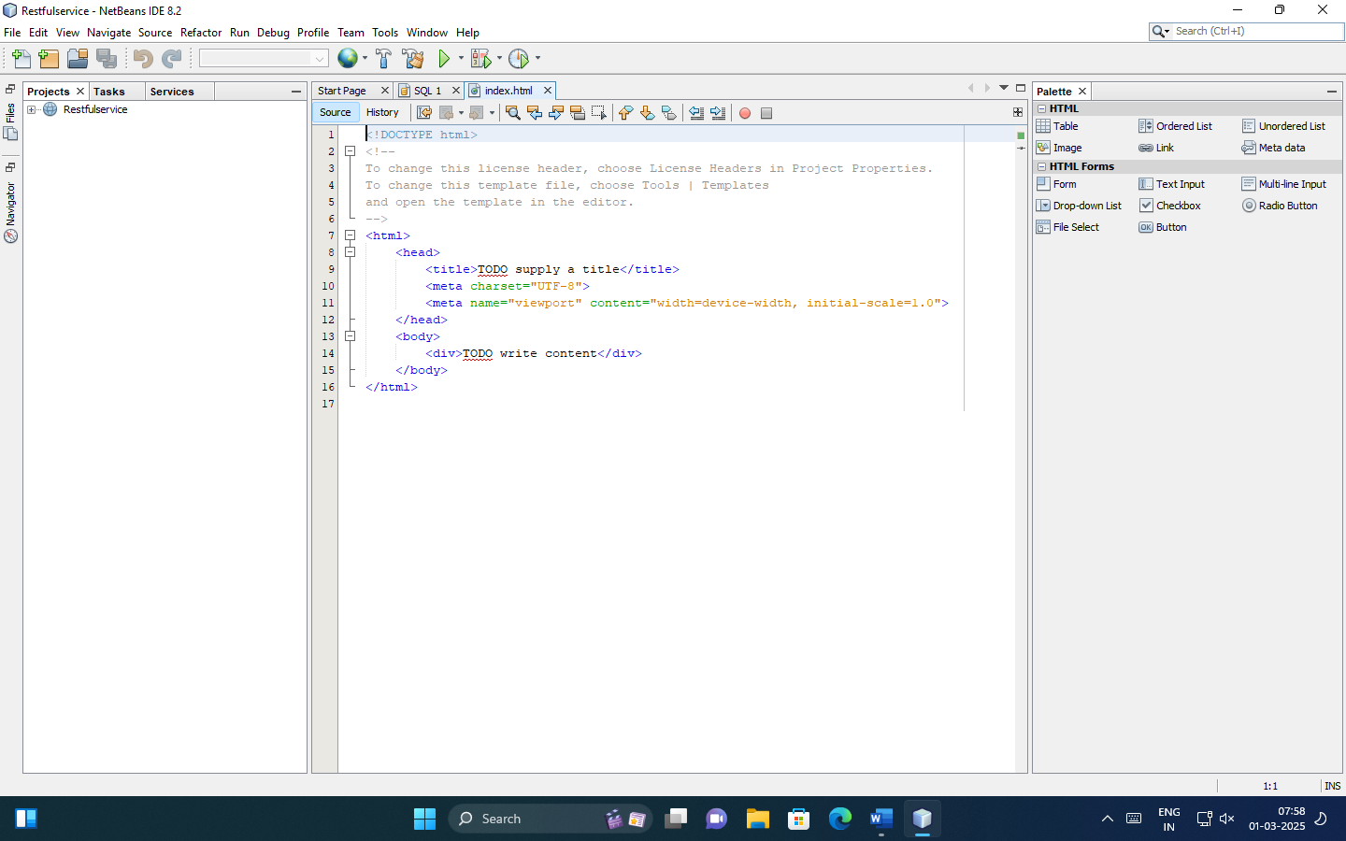

1. Right click on project name > Go to new > select “ RESTFUL web service from pattern”.

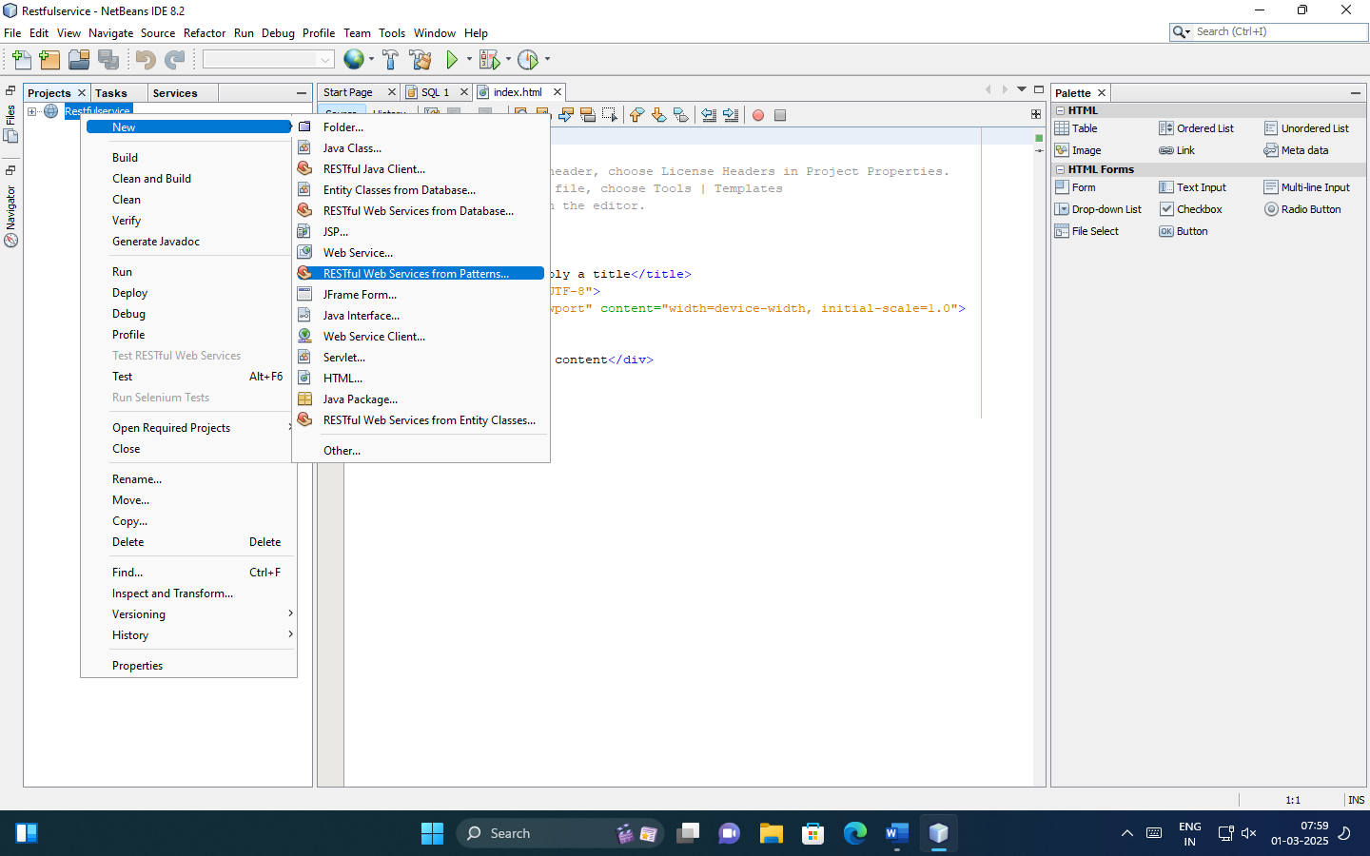

1. Select Simple Route Resource > click on next

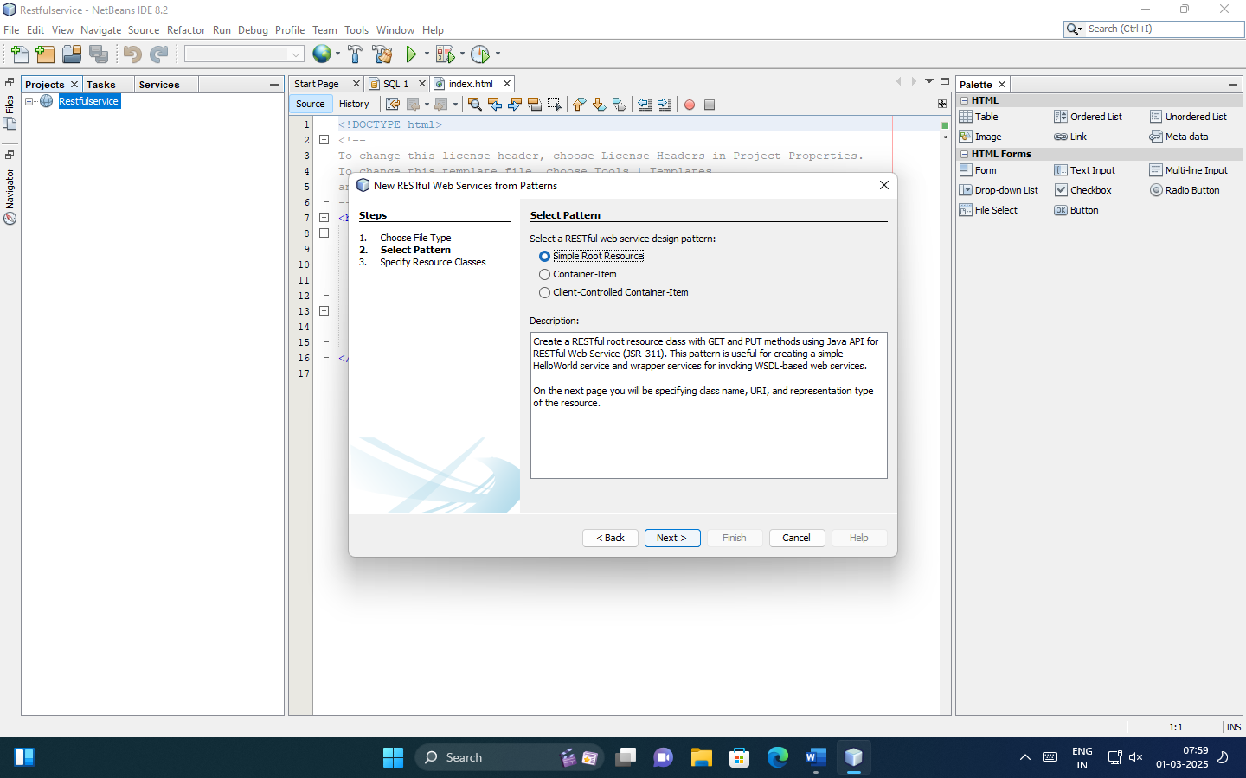

1. Specify resource classes.

Resource package: StringOptpackage

Path: generic

Class Name: StringOpr

MIME Type: text/html

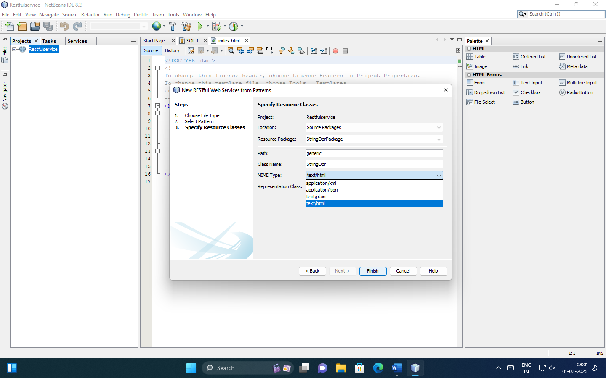

1. Go to StringOpr.java file and Write the code.

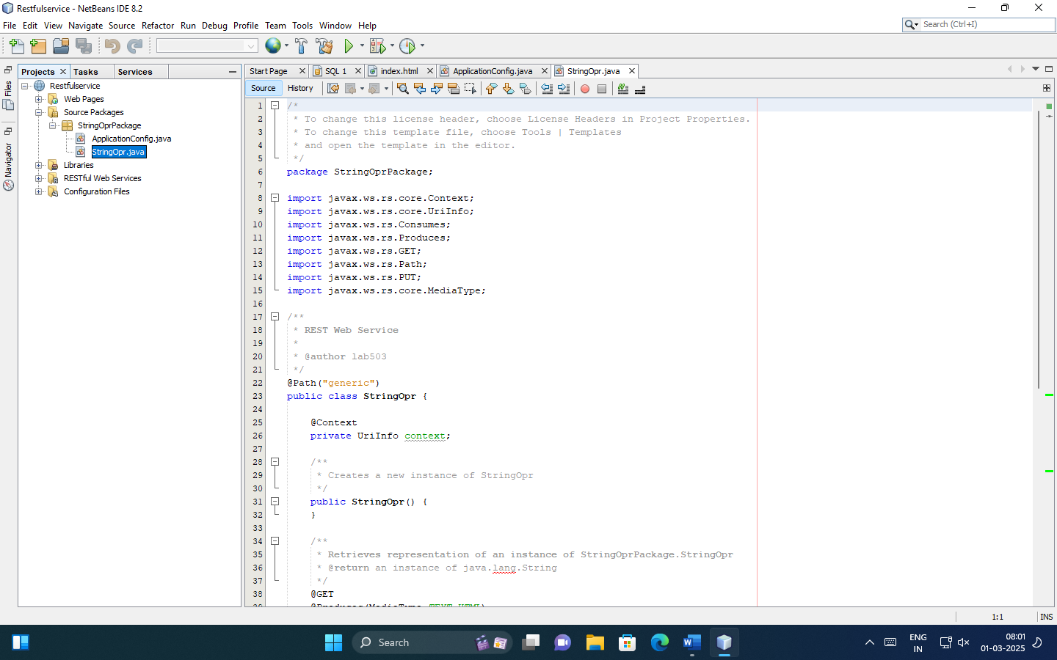

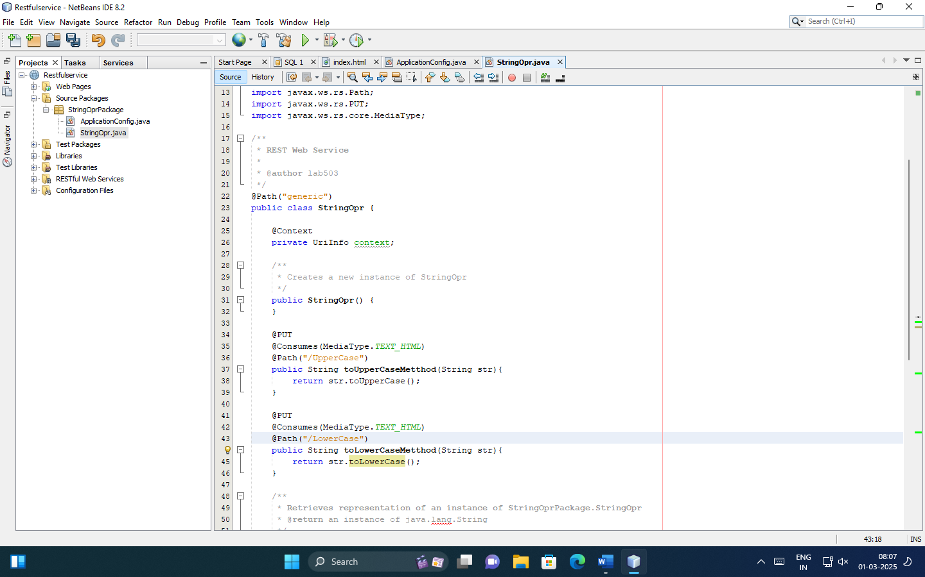

Code:

package StringOprPackage;

import javax.ws.rs.core.Context;

import javax.ws.rs.core.UriInfo;

import javax.ws.rs.Produces;

import javax.ws.rs.Consumes;

import javax.ws.rs.GET;

import javax.ws.rs.Path;

import javax.ws.rs.PUT;

import javax.ws.rs.core.MediaType;

/**

* REST Web Service

*

* @author lab503

*/

@Path("generic")

public class StringOpr {

@Context

private UriInfo context;

/**

* Creates a new instance of StringOpr

*/

public StringOpr() {

}

**@PUT**

**@Consumes(MediaType.TEXT_HTML)**

**@Path("/UpperCase")**

**public String toUpperCaseMethod(String str) {**

**return str.toUpperCase();**

**}**

**@PUT**

**@Consumes(MediaType.TEXT_HTML)**

**@Path("/LowerCase")**

**public String toLowerCaseMethod(String str) {**

**return str.toLowerCase();**

**}**

/**

* Retrieves representation of an instance of StringOprPackage.StringOpr

* @return an instance of java.lang.String

*/

@GET

@Produces(MediaType.TEXT_HTML)

public String getHtml() {

//TODO return proper representation object

throw new UnsupportedOperationException();

}

/**

* PUT method for updating or creating an instance of StringOpr

* @param content representation for the resource

*/

@PUT

@Consumes(MediaType.TEXT_HTML)

public void putHtml(String content) {

}

}

1. Right click on project name > Click “Clean” .

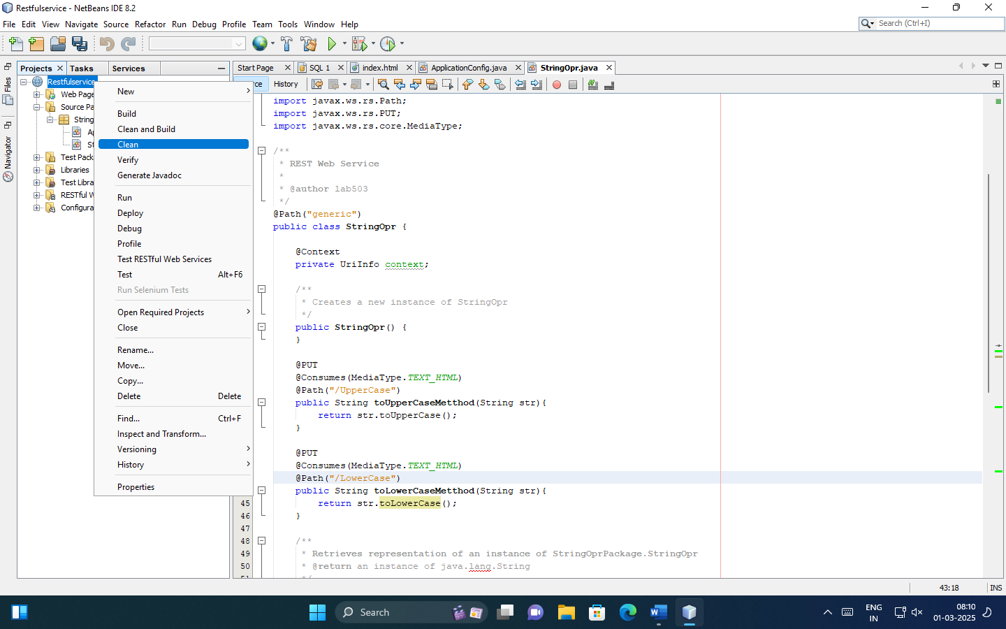

1. Right click on project name > Click “Build”.

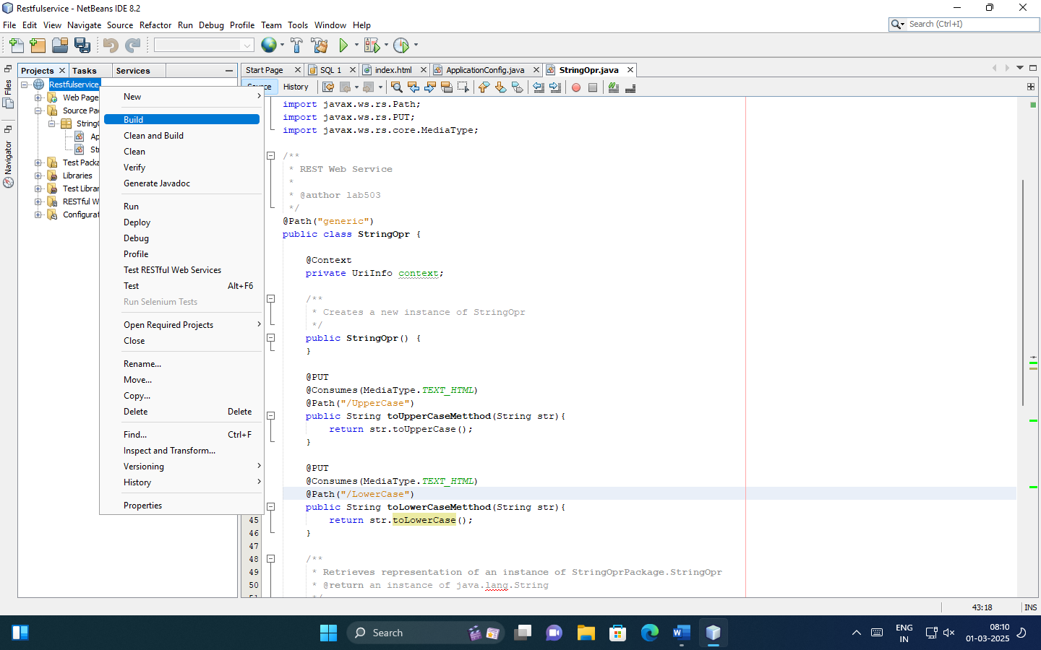

1. Right click on project and select Test RESTFUL Web Service.

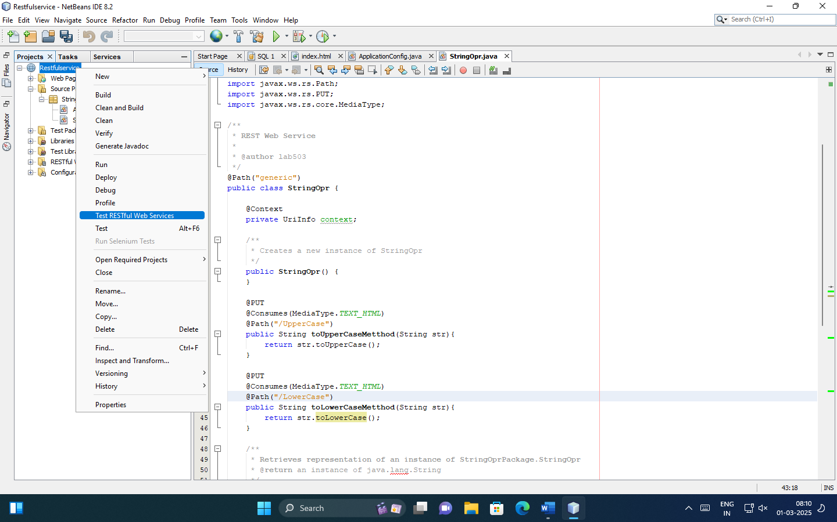

1. Select Web Test client in project .

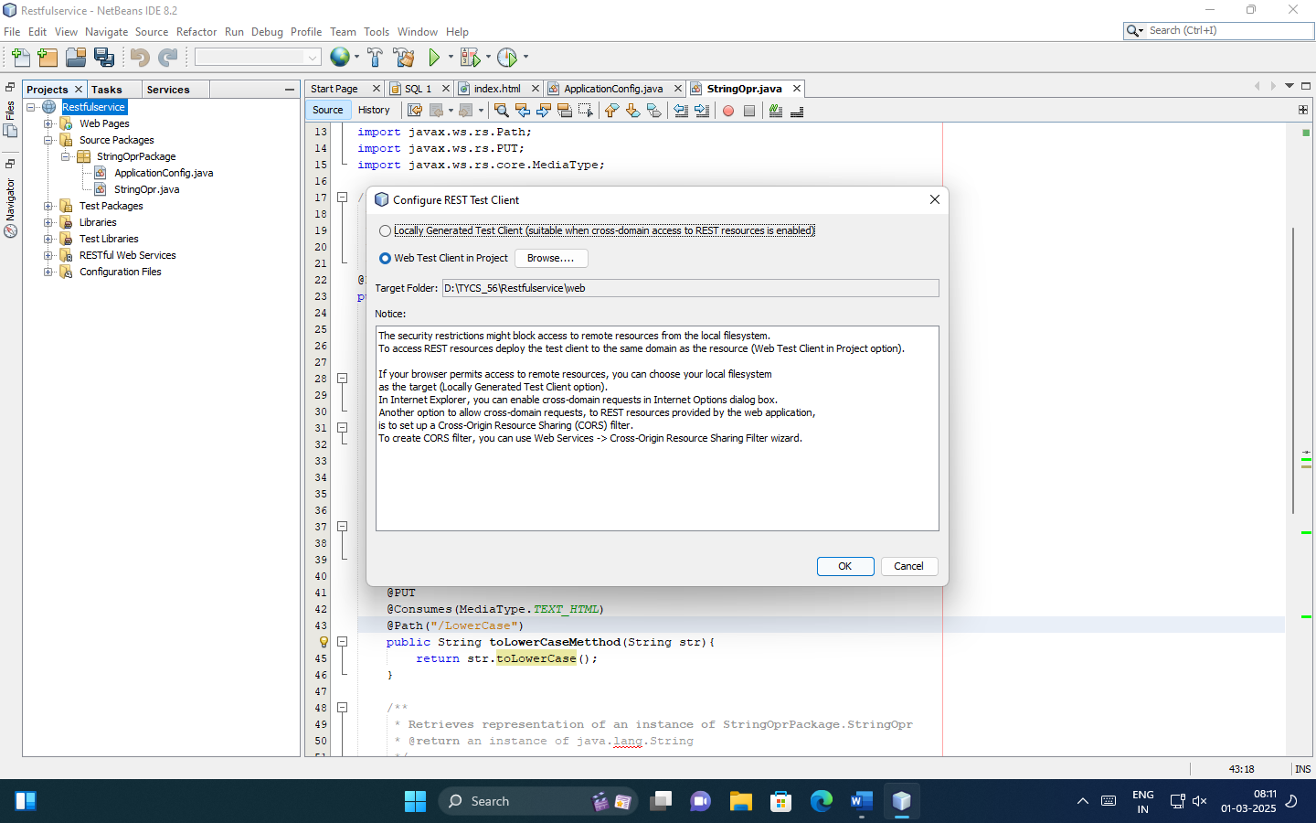

1. Output :

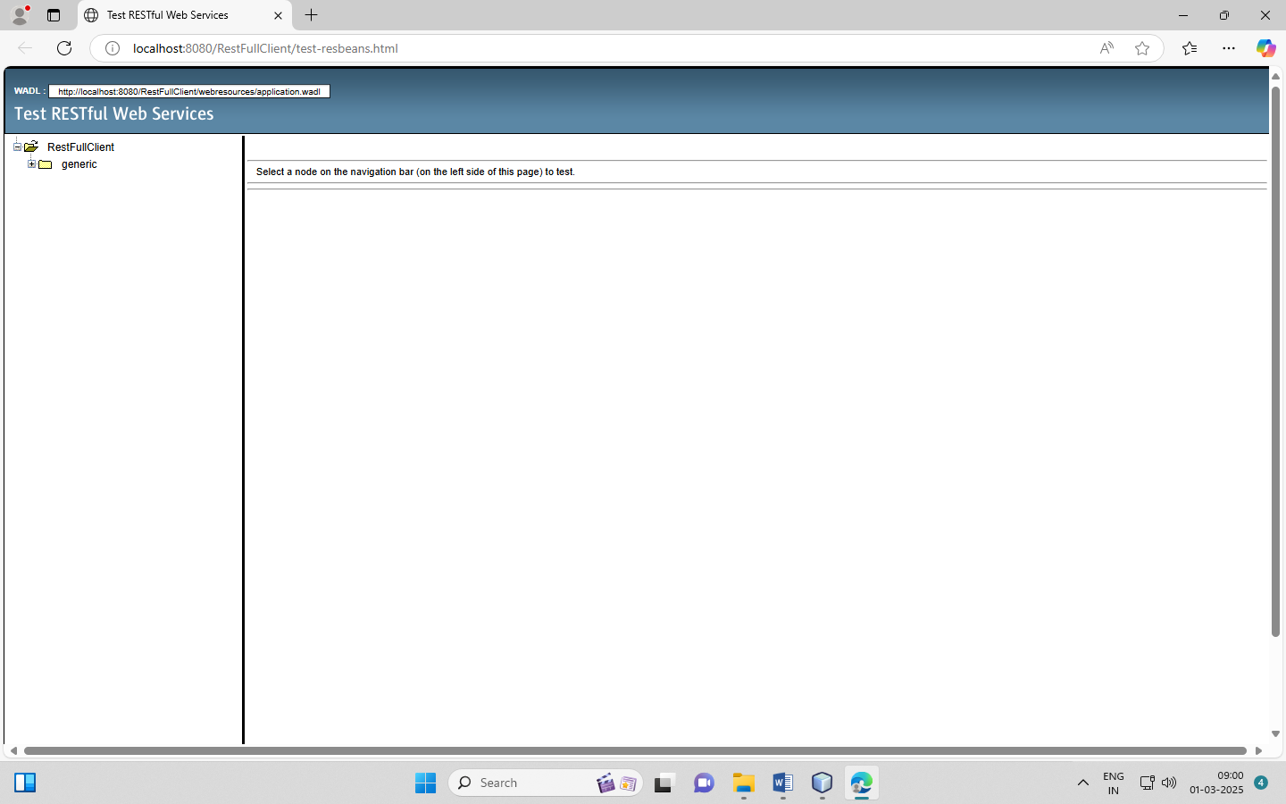

* **For Client:**
* **Step :**

1. Creating Java client > click on File > select new project

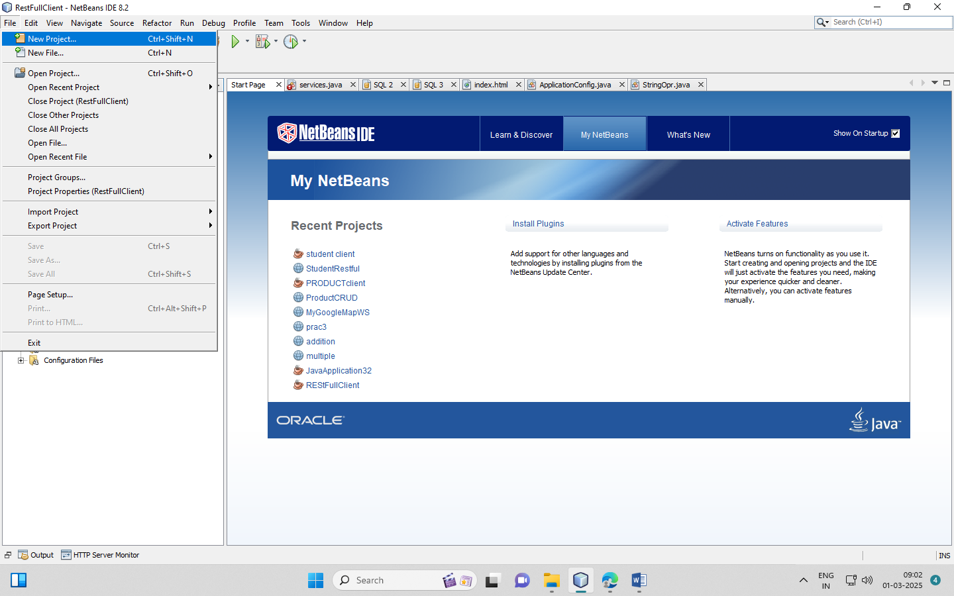

1. Select Java

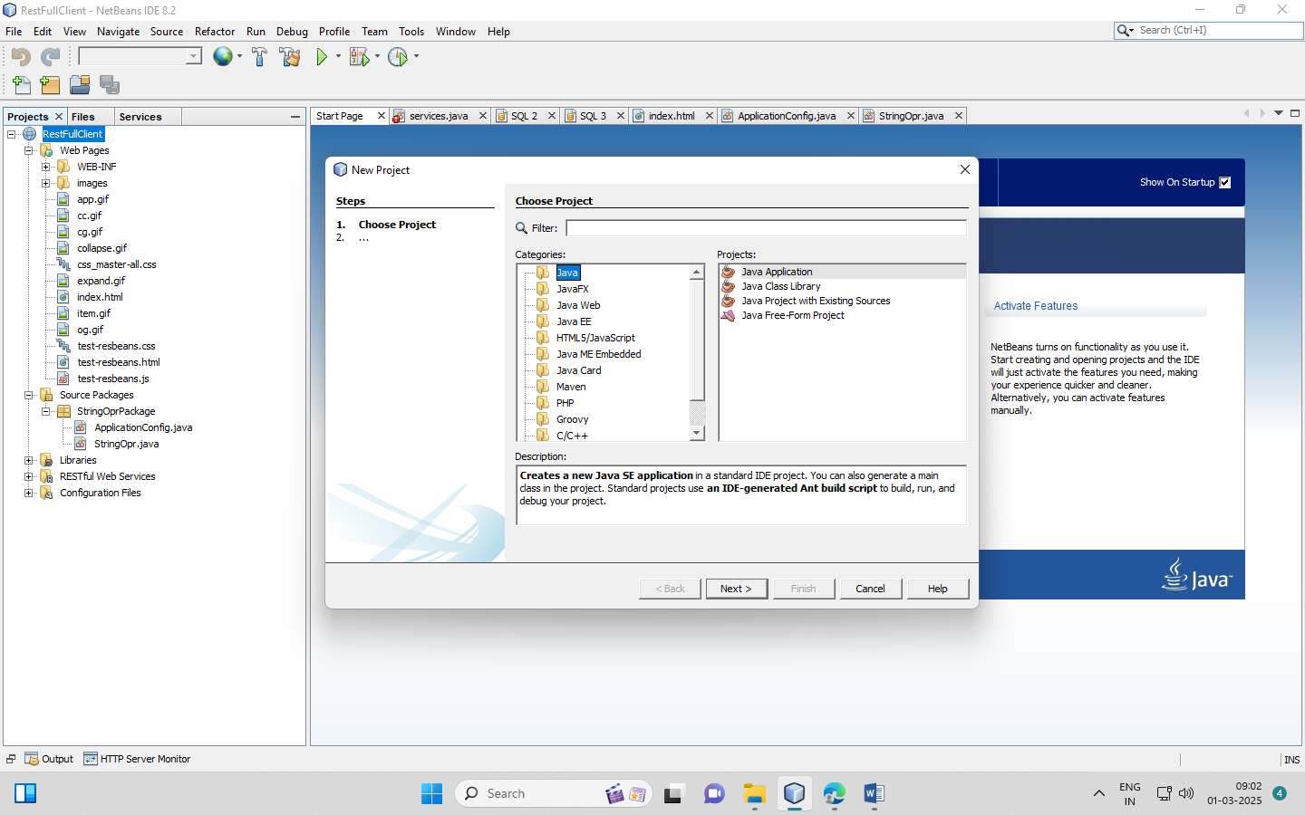

1. Select java application > click on next

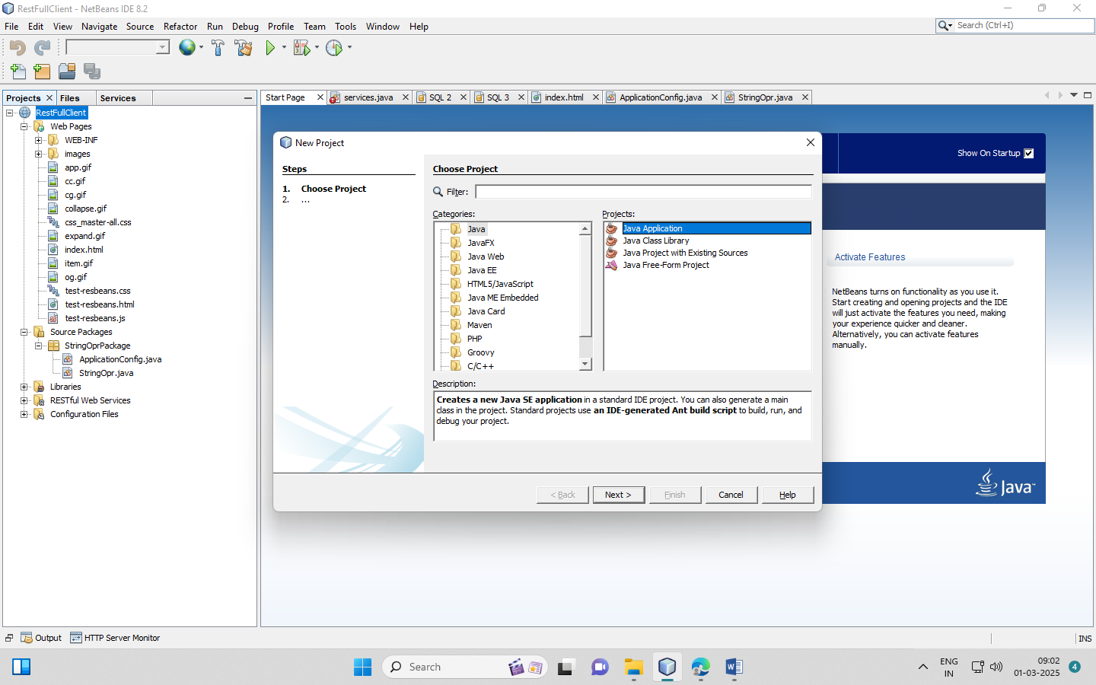

1. Select java application project > right click on it > select new > select restful java client

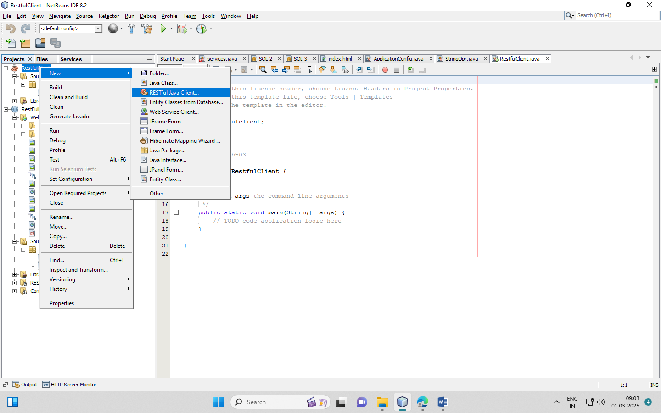

1. Give the name of class and set the package name > select “from project” option > click on next.

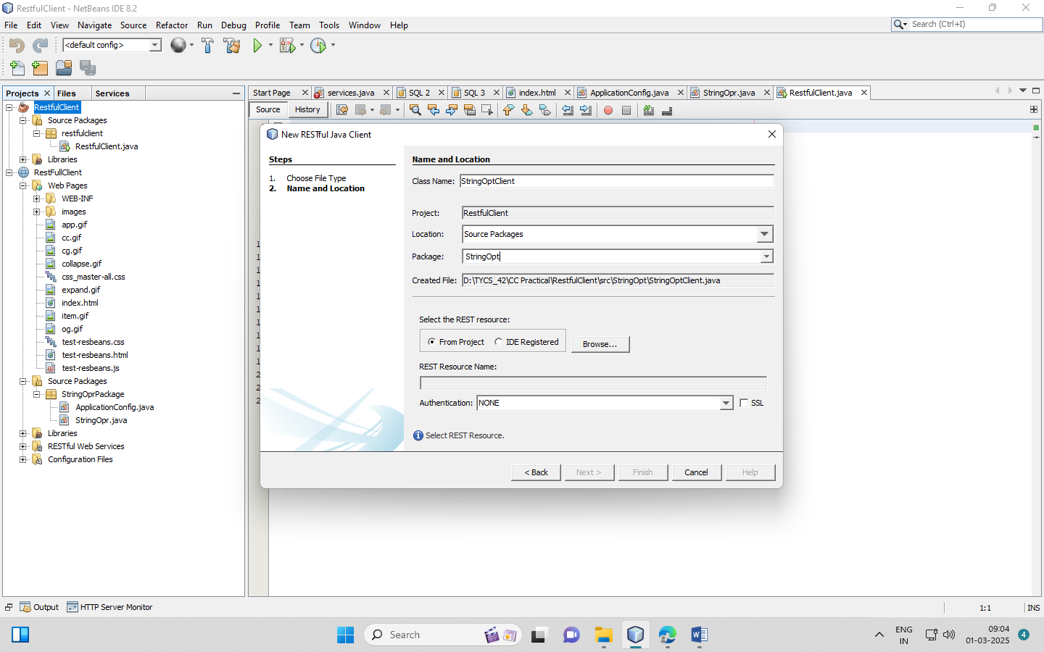

1. Select rest resources > click on ok

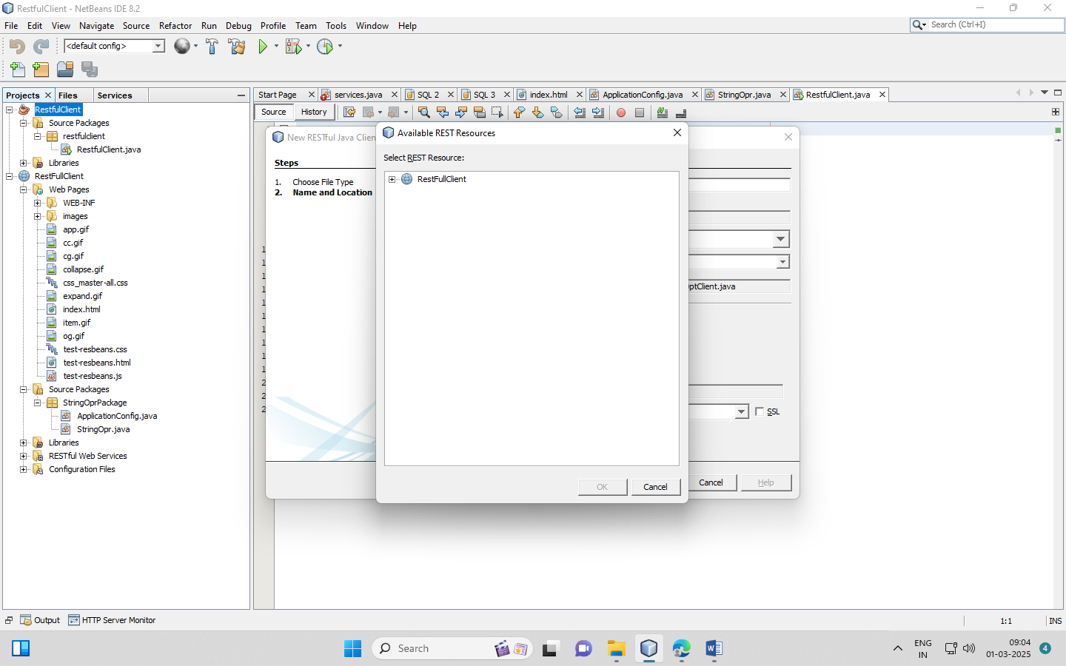

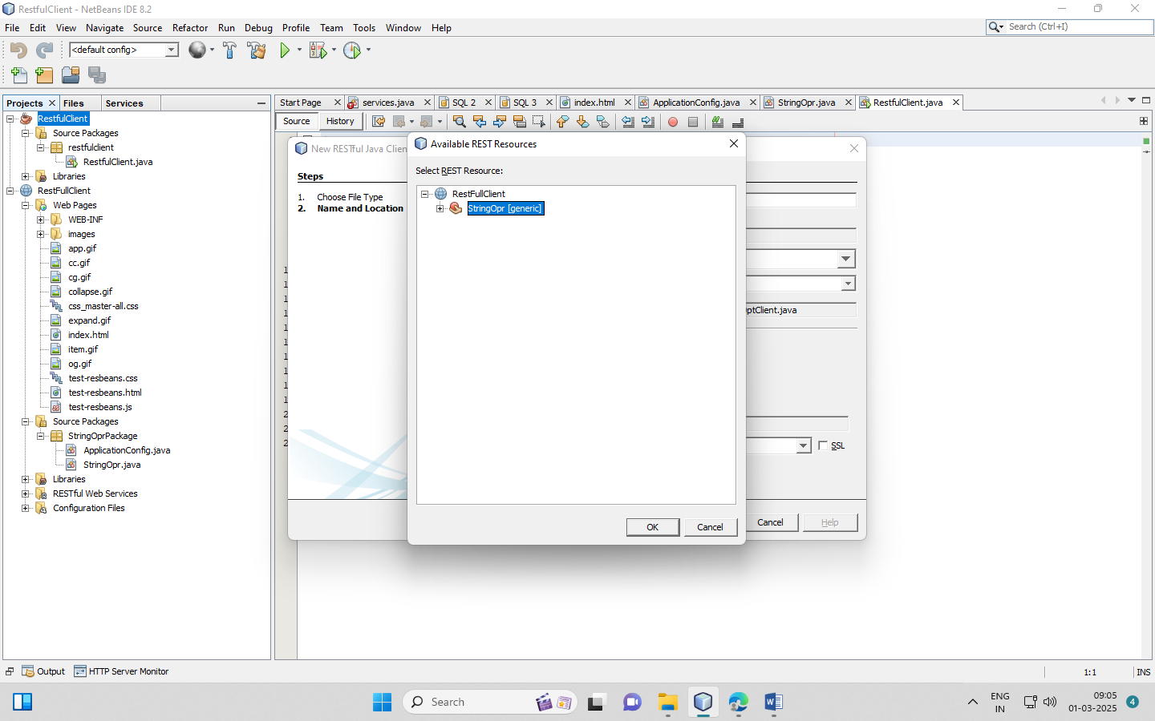

1. Write the code

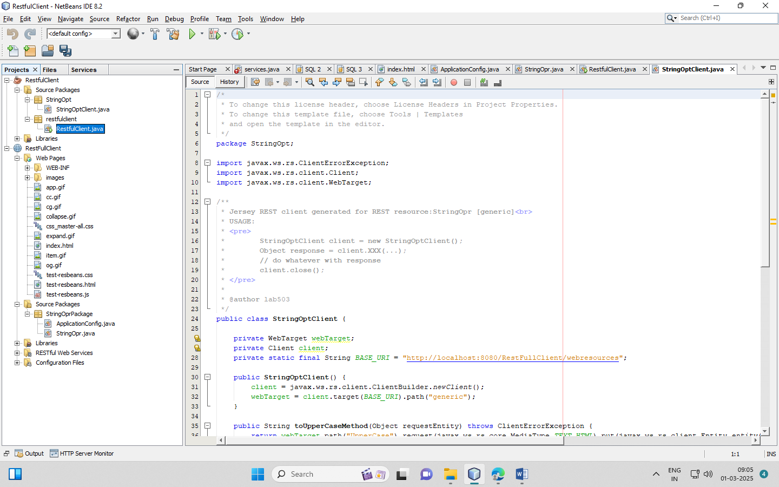

* Code:

/*

* To change this license header, choose License Headers in Project Properties.

* To change this template file, choose Tools | Templates

* and open the template in the editor.

*/

package restfulclient;

import StringOpt.StringOptClient;

/**

*

* @author lab503

*/

public class RestfulClient {

/**

* @param args the command line arguments

*/

public static void main(String[] args) {

// TODO code application logic here

**StringOpt.StringOptClient client = new StringOptClient();**

**System.out.println(client.toUpperCaseMethod("cloud computing"));**

**System.out.println(client.toLowerCaseMethod("CLOUD COMPUTING"));**

}

}

1. Right click on file > select run file option

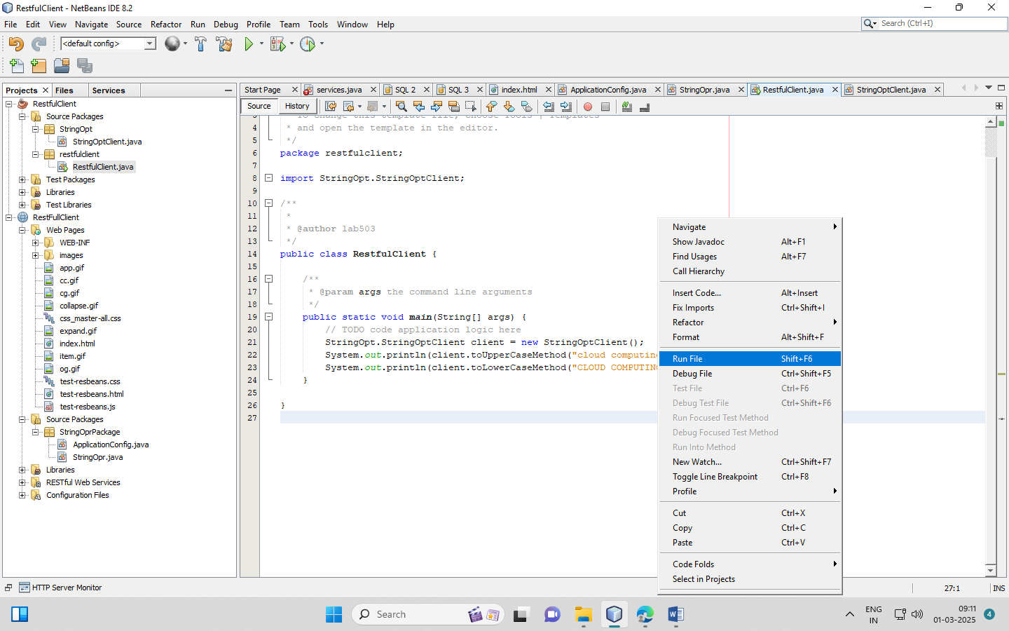

1. Output:

